SCHOLARSHIPS
- The scholarship selection committee will choose the scholarship recipient(s).
- Scholarship is for $1,000 per recipient for undergraduate studies. Each scholarship is paid directly to Texas A&M University, deducted from the fee statement at one-half of the scholarship amount per semester. First payment will be made for the upcoming Fall and following Spring semester.
- A student may only receive the Parker County Aggie Moms’ Club Scholarship one time. (Either as a graduating high school senior or as a TAMU student)
- All applications will be submitted by email.
- Applications and references must be emailed by: Wednesday, March 31, 2021 at midnight CST

ELIGIBILITY
Any current Texas A&M student that meets the following criteria:
- Current TAMU GPA of 2.5 or above
- Student must be currently attending Texas A&M University in College Station or Galveston as a full-time student (12 or more hours) and planning to enroll in the Fall 2021 and Spring 2022 as an undergraduate
- The students meet one of the following residence requirements. The student or the student’s parent/guardian must reside in:
  - Parker County, Texas
  - or in one of the following zip codes: 08854, 11572, 15085, 27526, 30319, 32765, 60515, 76008, 76020, 76052, 76066, 76082, 76085, 76086, 76087, 76088, 76248, 76449, 76485, 87111, 96818
- All information must be completed and applications must be signed. Incomplete applications will not be considered.

CHECK-OFF LIST
1. Fill in the application completely. The application is available in MS Word. You may need to write in your TAMU ID number at the bottom of the page. Please print to pdf before emailing.
2. Include college transcript. This does not need to be an official transcript from the registrar – a copy is sufficient.
3. Two letters of recommendation:
- one from a college professor/advisor and
- one personal recommendation, preferably from someone in the community who knows your leadership abilities or has been involved with you in extra-curricular activities (church, volunteer organizations, employer etc.).
Recommendation letters shall be emailed directly to the scholarship committee at pcam.2021ag@gmail.com. The recommendation letter should include the students Aggie ID number. Deadline is Wednesday, March 31, 2021 at midnight CST.
4. Sign the application and obtain parent/guardian signature if under 18 (electronic signatures will be accepted)
5. Email the completed application and transcript to:
Parker County Aggie Moms’ Club
Attention: Scholarship Committee
pcam.2021ag@gmail.com
Please include your cell phone number in the application in case there are any questions or issues with the electronic submittal

6. Applications must be emailed by Wednesday, March 31, 2021
AFTER APPLICATION IS RECEIVED: An e-mail confirmation will be sent to all applicants and will indicate if the application was complete or not and received by the deadline.
Complete applications will be reviewed by the scholarship selection committee. All applicants will be notified via email whether their application was selected or not by June 1, 2021.
Scholarship winners will be requested to email two photos for the Howdy Party.
Questions: All questions shall be in writing. Email questions to: pcam.2021ag@gmail.com; Emails should contain “Parker County A&M Scholarship” in the subject line.
Tips for Completing the Application in MS Word
Click on the locations in the document that state “click here”. The tables will expand to fit the information provided. Please limit the size of each table and each essay question to a maximum of two pages.
Spell check is not available in the form, so for essay answers, consider typing your response in a separate document, save it and spell-check it and then copy and paste your answer into the form.
The applicant ID number in the footer should automatically appear once the last four digits of the applicant’s TAMU ID number is entered.
For signature page – this may be printed and a photograph of the signed page can be sent in a separate file if that is easier for you.
Convert to PDF and Scanning Documents
Please convert the MS Word Document to PDF. Digital signatures on the pdf will be accepted. (or print and scan the signature page only).
Add your transcript to the pdf file.
Encrypting: You are not required to encrypt your application, but if you can please do so. Please use PCAM2021 as the password; or submit a separate email with the encryption password.
Here are some tips on how to encrypt an Adobe Acrobat document (if you have access to Adobe Acrobat – not the reader)
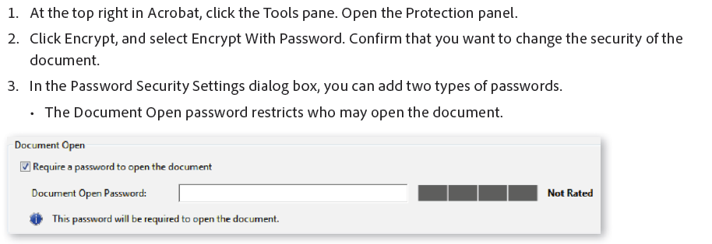
Please do not lock the document from other changes.
Note from Scholarship Chair
Congratulations on a great selection of college campuses. I hope that you are enjoying the Spirit of Aggieland. Good luck on your scholarship application.
Gig ‘em!

Ramalou Prince

Date: Click here to enter text.
Email Address: Click here to enter text.

PERSONAL INFORMATION
Name | Click here to enter text.Applicant's Name
Address | Click here to enter text.
Phone | Click here to enter text.
Texas A&M Student ID | Click here to enter text.
TAMU Campus Attending this upcoming fall: | ☐College Station ☐ Galveston
Parents’ name and address | Click here to enter text.
Do you or your parent/guardian reside in Parker County, Texas? | ☐ Yes ☐ No  If no, please provide the residential zip code for parent/guardian for eligibility: Click here to enter text.
List any siblings and their ages | Click here to enter text.
U.S. Citizen | ☐ Yes ☐ No  If no, please answer these questions:  Are you a permanent resident in the U.S.? ☐ Yes ☐ No  Are you obtaining U.S. Citizenship? ☐ Yes ☐ No

TAMU ID #: Click here to enter text.

EDUCATION RECORD
A&M cumulative GPA: | Click here to enter text. | Date to enter A&M: | Click here to enter text.
Expected graduation date: | Click here to enter text. | Class of (at A&M): | Click here to enter text.
Major(s): | Click here to enter text. | Expected degree: | Click here to enter text.

Reminder: Be sure to include a copy of your most recent transcript
Please list any school, employment and/or community extra-curricular activities in which you have participated while in college. (Please limit to no more than 7 activities) Please limit the size of the table to a maximum of one page.
Activity, organization or employer | Offices, duties and/or positions | Hours per week related to activity or work experience and total number of years | What did you learn?
Click here to enter text. | Click here to enter text. | Click here to enter text. | Click here to enter text.
Click here to enter text. | Click here to enter text. | Click here to enter text. | Click here to enter text.
Click here to enter text. | Click here to enter text. | Click here to enter text. | Click here to enter text.
Click here to enter text. | Click here to enter text. | Click here to enter text. | Click here to enter text.
Click here to enter text. | Click here to enter text. | Click here to enter text. | Click here to enter text.
Click here to enter text. | Click here to enter text. | Click here to enter text. | Click here to enter text.
Click here to enter text. | Click here to enter text. | Click here to enter text. | Click here to enter text.

Awards and Honors (College and High School) Please limit the size of the table to a maximum of one page.
Year(s) Received | Name of Award/Honor | Name of Organization | Brief description of award and what it meant to you
Click here to enter text. | Click here to enter text. | Click here to enter text. | Click here to enter text.
Click here to enter text. | Click here to enter text. | Click here to enter text. | Click here to enter text.
Click here to enter text. | Click here to enter text. | Click here to enter text. | Click here to enter text.
Click here to enter text. | Click here to enter text. | Click here to enter text. | Click here to enter text.
Click here to enter text. | Click here to enter text. | Click here to enter text. | Click here to enter text.
Click here to enter text. | Click here to enter text. | Click here to enter text. | Click here to enter text.
Click here to enter text. | Click here to enter text. | Click here to enter text. | Click here to enter text.

Essay Question What are your plans and goals for the first five years upon graduating from A&M? Please limit the answer to this essay question to a maximum of two pages.

Click here to enter text.

Student Certification:

I certify that, to the best of my knowledge, the information on this application is accurate and complete and that the signatures on this page are valid. I understand that should either signature be found invalid, my application will be removed from consideration for this scholarship. I also certify that information in my application may be used in press releases and other public forums if I am selected for the scholarship.

Student’s Signature REQUIRED | Date & Age

Parent/Guardian Signature (if applicant is under 18) | Date

Attach:
Copy of your TAMU transcript (unofficial is acceptable)

References:
Have two references submit letters or emails of recommendation.
Please include contact Information for references:
Click here to enter text.
Click here to enter text.

Your references should directly send an email to pcam.2021ag@gmail.com

